Some Extensions of Matrix Visualization: the GAP Approach

Chun-houh Chen
Institute of Statistical Science, Academia Sinica, Taiwan

Exploratory data analysis (EDA, Tukey, 1977) has been extensively used for nearly 40 years yet boxplot and scatterplot are still the major EDA tools for visualizing continuous data in the 21st century. Many extended modules of matrix visualization via the Generalized Association Plots (GAP) approach have been developed or under developing. Some details of the following MV modules will be provided in this talk:

1. Matrix visualization for high-dimensional categorical data structure
For categorical data, MCA (multiple correspondence analysis) is most popular for visualizing reduced joint space for samples and variables of categorical nature. But similar to it’s continuous counter part: PCA (principal component analysis), MCA loses its efficiency when data dimensionality gets really high. In this study we extend the framework of matrix visualization from continuous data to categorical data. Categorical matrix visualization can effectively present complex information patterns for thousands of subjects on thousands of categorical variables in a single matrix visualization display.

2. Matrix Visualization for High-Dimensional Data with a Cartography Link
When an cartography link is attached to each subject of a high-dimensional categorical data, it is necessary to use a geographical map to illustrate the pattern of subject (region)-clusters with variable-groups embedded in the high-dimensional space. This study presents an interactive cartography system with systematic color-coding by integrating the homogeneity analysis into matrix visualization.

3. Matrix visualization for symbolic data analysis
Symbolic data analysis (SDA) has gained popularity over the past few years because of its potential for handling data having a dependent and hierarchical nature. Here we introduce matrix visualization (MV) for visualizing and clustering SDA data using interval-valued symbolic data as an example; it is by far the most popular SDA data type in the literature and the most commonly encountered one in practice. Many MV techniques for visualizing and clustering conventional data are converted to SDA data, and several techniques are newly developed for SDA data. Various examples of data with simple to complex structures are brought in to illustrate the proposed methods.

4. Covariate-adjusted matrix visualization via correlation decomposition
In this study, we extend the framework of matrix visualization (MV) by incorporating a covariate adjustment process through the estimation of conditional correlations. MV can explore the grouping and/or clustering structure of high-dimensional large-scale data sets effectively without dimension reduction. The benefit is in the exploration of conditional association structures among the subjects or variables that cannot be done with conventional MV.

Several biomedical examples including an US hospital comparison profile will be employed for illustrating the versatility of the GAP approach matrix visualization.

Generalized Association Plots (GAP) http://gap.stat.sinica.edu.tw/Software/

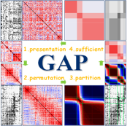
GAP basic concept 2. GAPsoftware
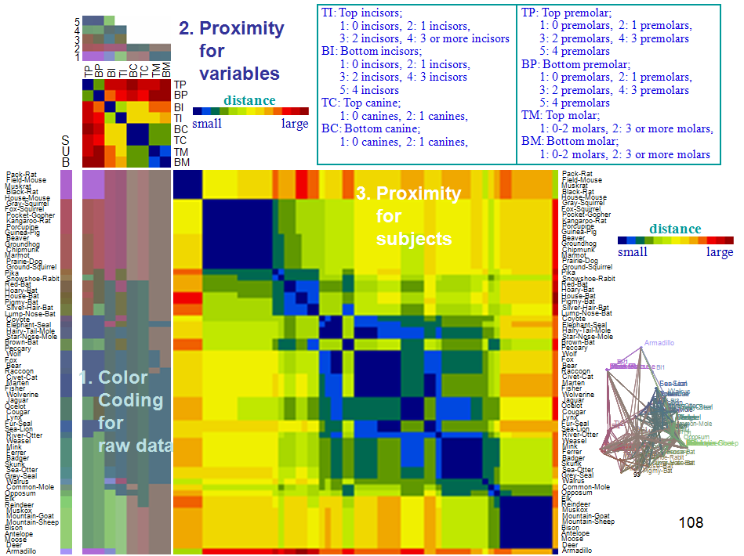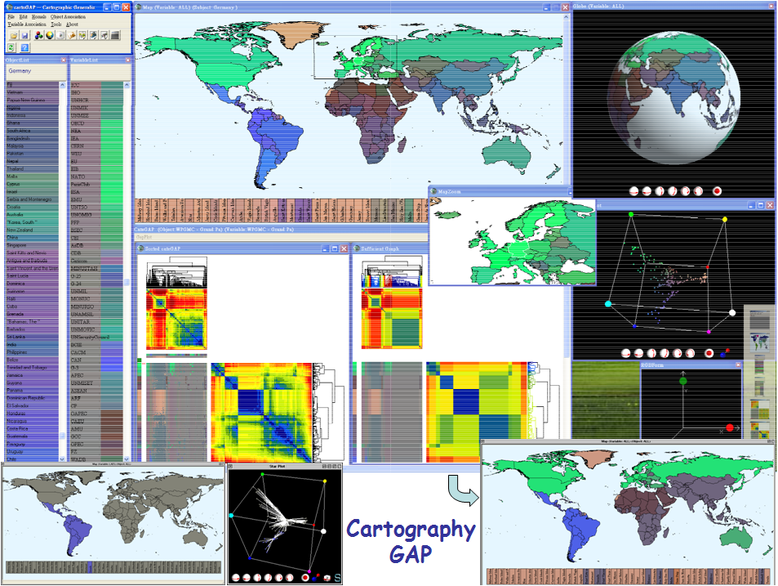
Categorical Matrix Visualization Cartography Matrix Visualization
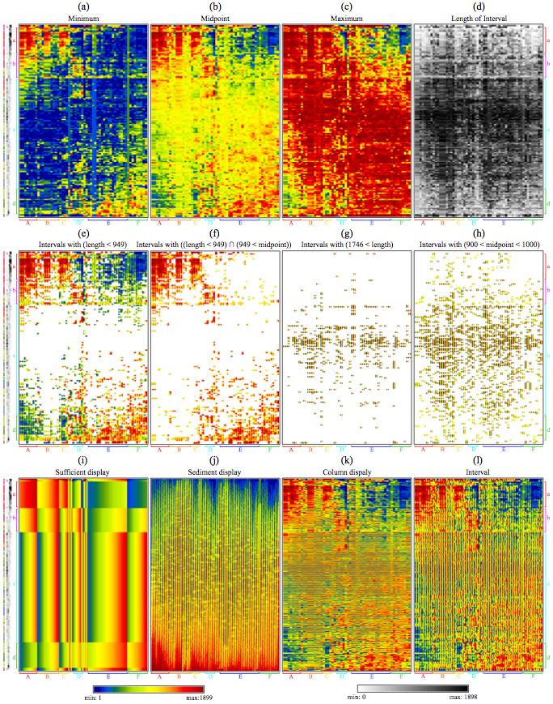
MV for for symbolic data analysis (SDA)

A. MV for the crabs data B. MV With R2E seriation. C. MV adjusted for continuous D. MV adjusted for discrete
with covariates. with 1st PC attached. COV, 1st PC with R2E. COV (species, sex) with R2E
Covariate-adjusted MV

